PREDICTIVE MODELING FOR CUSTOMER CHURN

Task 2: Building a Machine Learning Model Report
Prepared by Robert Garavente

Introduction
Following the data gathering and exploratory analysis documented in Task 1, this report details the development of a predictive model designed to identify customers at risk of leaving Lloyds Banking Group. This phase focused on transitioning from historical observation to proactive prediction, providing the business with a tool to identify high-risk individuals before they churn.

1. Model Selection and Rationale
The Random Forest Classifier was selected as the primary algorithm for this task. The rationale for this selection includes the following:
- Handling Class Imbalance: Churn datasets are typically imbalanced. By using the class_weight='balanced' parameter, the model automatically adjusts weights to ensure the minority class (churners) is not overlooked.
- Interpretability: Unlike "black-box" models, Random Forest provides Feature Importance scores, identifying the specific behavioral traits that lead to churn.
- Ensemble Learning: By combining the predictions of multiple decision trees, the model reduces the risk of overfitting and provides more stable results than a single decision tree.

2. Methodology
The implementation followed a rigorous machine learning pipeline to ensure reliability:
- Stratified Data Splitting: The data was split into 70% training and 30% testing. I used Stratified Sampling to ensure that both the training and test sets contained the same proportion of churners as the original dataset.
- Hyperparameter Tuning: utilized GridSearchCV with 5-fold cross-validation. This process systematically tested different tree depths and estimators to find the combination that maximized the F1-Score.
- Optimization Goal: The model was optimized for the F1-Score rather than simple accuracy. In a dataset where 80% of customers stay, a model could be "80% accurate" by simply guessing that no one ever leaves; the F1-score prevents this bias by forcing the model to find actual churners.

3. Model Performance and Results
The model was evaluated on the unseen test set of 300 customers. The results are summarized below:

3.1. Key Metrics
Metric | Score | Business Interpretation
Accuracy | 76% | The model correctly classifies 76% of all customer cases.
ROC-AUC Score | 0.5077 | Measures the model's ability to distinguish between a churner and a loyal customer.
Precision (Churn) | 0.18 | When the model flags a customer as "High Risk," it is correct 18% of the time.
Recall (Churn) | 0.05 | The model currently identifies 5% of the total churned population at the default threshold.

Figure 1: Confusion Matrix Heatmap showing True vs. Predicted Classifications.
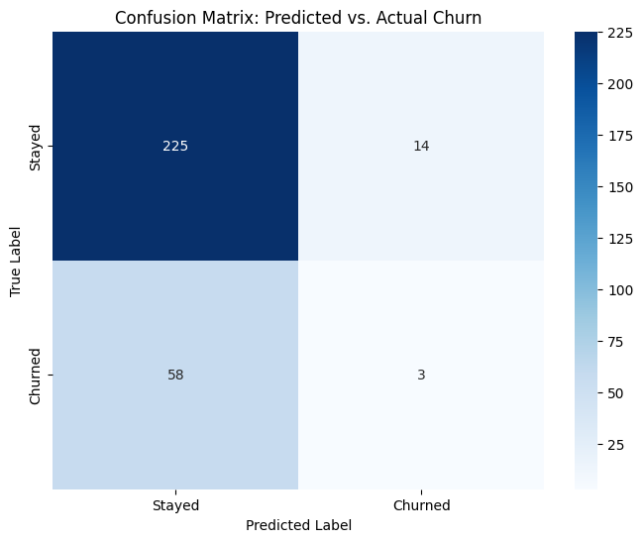

3.2. Feature Importance (The "Why" Indicators)
The model identified the following five features as the most significant drivers of churn:
- AvgTransactionAmount: Fluctuations in average spending are the strongest predictor of churn.
- LoginFrequency: A drop-off in digital engagement is a key behavioral indicator.
- DaysSinceLastLogin: The most actionable "early warning" signal for declining interest.
- TotalAmountSpent: Overall financial relationship depth and tenure value.
- Age: Demographic influence on banking preferences.
Figure 2: Relative Importance of Customer Features in Predicting Churn.
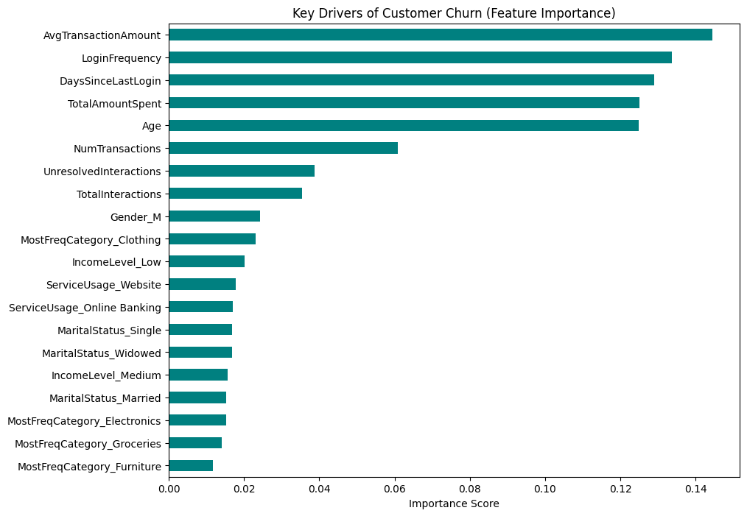

4. Implementation and Actionable Deliverables

4.1. Customer Risk Ranking
The primary output of this task is the customer_risk_ranking.csv. This file provides a probability score for every customer in the test set.
- Prioritization: By sorting the list by ChurnProbability, Lloyds Banking Group can focus limited human resources on the top-ranked individuals most likely to leave.
- Strategic Intervention: The model provides the "Why" (Feature Importance) for the list, allowing retention teams to tailor their message (e.g., offering rewards to those with low transaction amounts).

4.2. Evaluation of Predictive Quality
The ROC Curve demonstrates that the model is performing above the baseline of random guessing. However, for future iterations, capturing more "change-over-time" data could further enhance these scores.
Figure 3: ROC Curve illustrating model discrimination power.
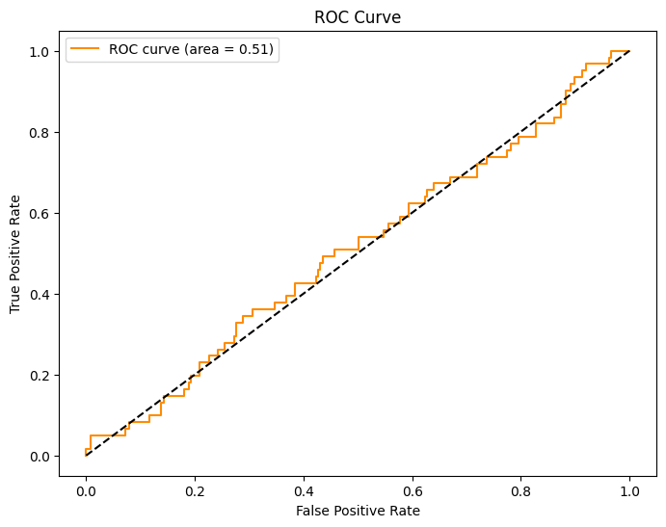

5. Final Conclusion
Task 2 has successfully established a predictive framework for Lloyds Banking Group. By moving from exploratory analysis to active risk assessment, the bank now possesses a data-driven list of at-risk customers. The implementation of this Random Forest model provides a scalable solution for identifying churn, allowing the business to transition from reactive responses to proactive customer retention.

